Mon. Nov. 2  Cereal  Teddy Grahams  Choice of Fruit  Juice  Milk | Mon. Nov. 9  Donut  String Cheese  Choice of Fruit  Juice  Milk | Mon. Nov. 16  Cereal  Graham Crackers  Choice of Fruit  Juice  Milk | Mon. Nov. 23  Cereal  Graham Crackers  Choice of Fruit  Juice  Milk | Mon. Nov. 30  Goldfish Crackers  String Cheese  Choice of Fruit  Juice  Milk
Tues. Nov. 3  Animal Crackers  Yogurt  Choice of Fruit  Juice  Milk | Tues. Nov. 10  Waffle  Choice of Fruit  Juice  Milk | Tues. Nov. 17  Biscuit w/  Egg & Sausage  Choice of Fruit  Juice  Milk | Tues. Nov. 24  Breakfast Pizza  Choice of Fruit  Juice  Milk
Wed. Nov. 4  Sausage Pancake  Choice of Fruit  Juice  Milk | Wed. Nov. 11  Breakfast Pizza  Choice of Fruit  Juice  Milk | Wed. Nov. 18  Cheese  Breadstick  Choice of Fruit  Juice  Milk | Wed. Nov. 25  No School  Thanksgiving Break
Thurs. Nov. 5  Apple Bosco  Stick  Choice of Fruit  Juice  Milk | Thurs. Nov. 12  Cinnamon  Pancakes  Choice of Fruit  Juice  Milk | Thurs. Nov. 19  Donut  Yogurt  Choice of Fruit  Juice  Milk | Thurs. Nov. 26  Thanksgiving  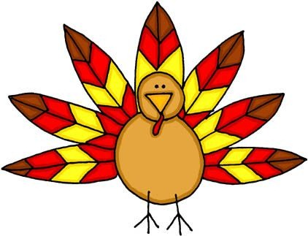
Fri. Nov. 6  Muffin w/  Egg Pattie  Choice of Fruit  Juice  Milk | Fri. Nov. 13  French Toast  Choice of Fruit  Juice  Milk | Fri. Nov. 20  Mini Pancakes  Choice of Fruit  Juice  Milk | Fri. Nov. 27  No School  Thanksgiving Break

Mon. Nov. 2  Max Cheese  Breadsticks  Butter Beans  Mixed Fruit  M & M Cookie  Milk | Mon. Nov. 9  Burrito  Broccoli w/  Cheese Sauce  Apple Slices  Cookie  Milk | Mon. Nov. 16  Pepperoni Pizza  Green Beans  Mixed Fruit  Cookie  Milk | Mon. Nov. 23  Hot Dog  French Fries  Oranges  Cookie  Milk | Mon. Nov. 30  Cheese Pizza  Cauliflower  Applesauce  Cookie  Milk
Tues. Nov. 3  Chicken Sandwich  Lettuce Salad  Pineapple  Crackers  Milk | Tues. Nov. 10  Ravioli  Green Beans  Peaches  Peanut Butter  Sandwich  Milk | Tues. Nov. 17  Fish Shapes  Lettuce Salad  Pineapple  Cheese  Breadstick  Milk | Tues. Nov. 24  Chicken Nuggets  Shredded Carrots  Grapes  Peanut Butter  Sandwich  Milk
Wed. Nov. 4  Egg & Sausage  Biscuit  Baby Carrots  w/ Dip  Pears  Hashbrown  Milk | Wed. Nov. 11  Sausage Pancake  Baked Beans  Banana  Graham Crackers  Milk | Wed. Nov. 18  Cheeseburger  Baked Beans  Applesauce  Cookie  Milk | Wed. Nov. 25  No School  Thanksgiving Break
Thurs. Nov. 5  Corn Dog  Green Beans  Orange  Cookie  Milk | Thurs. Nov. 12  Sloppy Jo  Corn  Applesauce  Cookie  Milk | Thurs. Nov. 19  Turkey Gravy  Mashed Potatoes  Fruit Salad  Pumpkin Pie  Hot Roll  Milk | Thurs. Nov. 26  Thanksgiving
Fri. Nov. 6  Chicken Strips  Mashed Potatoes  Dried Fruit  Hot Roll  Milk | Fri. Nov. 13  Chicken Noodle  Soup  Peas  Pears  Bosco Cheese  Breadstick  Milk | Fri. Nov. 20  Omelet  Baby Carrots  w/ Dip  Apple Slices  Cinnamon Toast  Milk | Fri. Nov. 27  No School  Thanksgiving Break

